**Sonia Delaunay**

Russian (1885-1974)

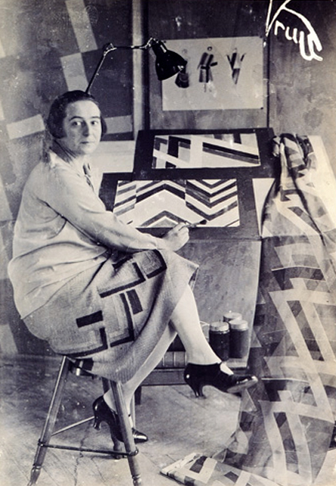

Sonia Delaunay was born in a small Ukrainian town called Gradizhsk. She went to St. Petersburg to live with her uncle, Henri Terk, and his wife when she was five. Her uncle adopted her. She received a good education, had access to great art collections, and traveled Europe spending summers in Finland. At sixteen, Delaunay's art teacher noticed her talent and encouraged her uncle and aunt to send her to Germany for further art training.

She later studied in Paris where she met her husband Robert, also an artist.

In 1911, Sonia and Robert Delaunay's son was born. Delaunay made a baby blanket by sewing together a patchwork quilt of brilliant colors, reminiscent of the bright colors of Ukrainian textiles and the brilliant sunsets of Ukraine. This quilt is an early example of Delaunay’s commitment to “Simultaneity”, a way of combining contrasting colors to create a sensation of movement in the eye. Both Sonia and Robert used it in their painting to evoke the fast pace of the new world.

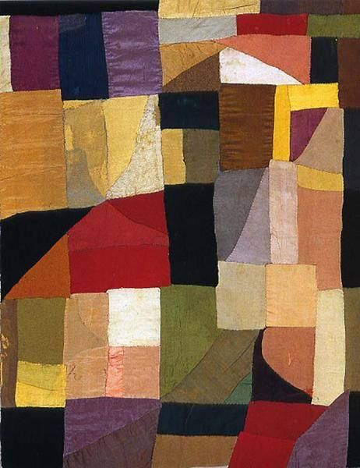

Sonia Delaunay, “Baby Blanket”

At the outbreak of World War I, Sonia and Robert exiled themselves to the Iberian Peninsula. After the war, she opened a workshop in Madrid called Casa Sonia. Delaunay sold the textiles, dresses, and home goods she designed in her shop.

Delaunay became popular at a moment in which fashion was significantly changing for young European women. The First World War demanded that women enter the workforce, and as a result, their attire had to change to accommodate their new tasks. After the war was over, it was difficult to convince these women to return to the more restrictive dress of the 1900s and 1910s. Delaunay designed for the New Woman, who was more interested in freedom of movement and expression.

Women’s clothing at the start of WWI.

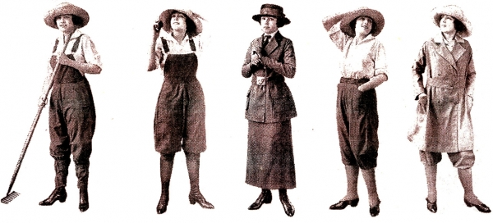

Examples of women’s work clothing during World War I.

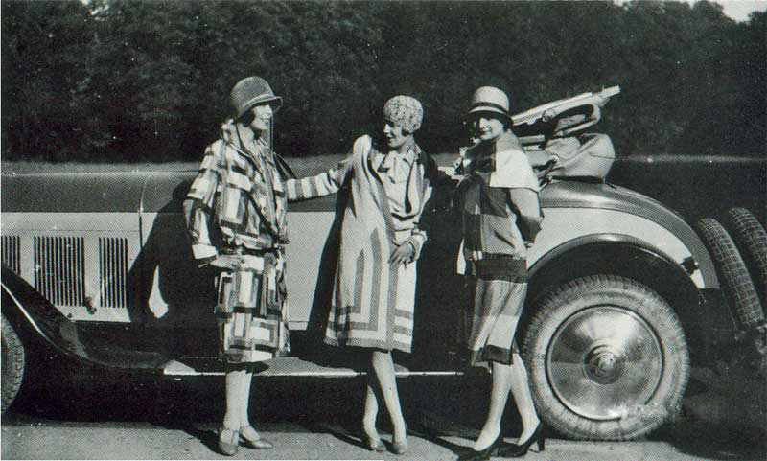

Delaunay’s designs for women’s clothing after WWI.

Delaunay also designed costumes for many stage productions. Sonia Delaunay’s contribution to French art and design was acknowledged by the French government in 1975 when she was named an officer of the Legion d’Honneur, the highest merit awarded to French civilians.

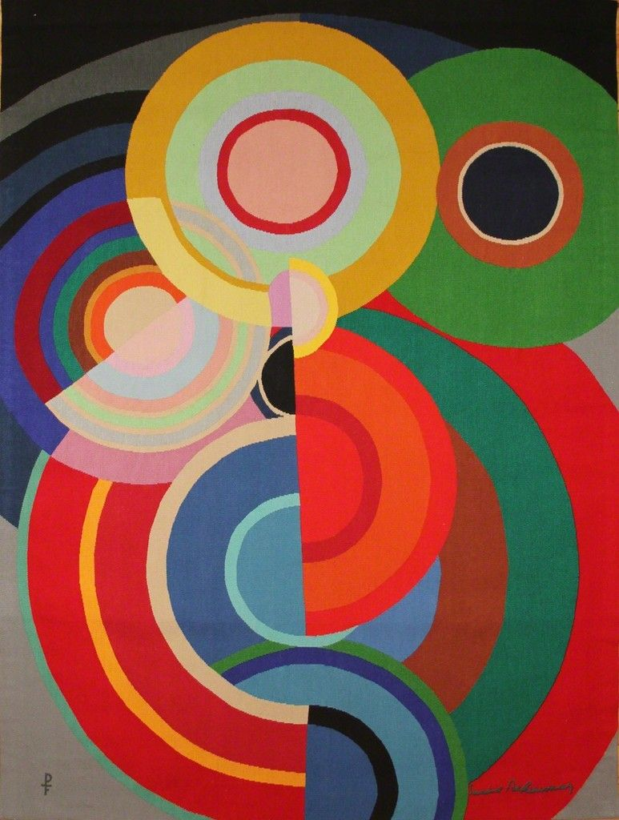

“Petite Automne”, 1939/1971)