**Color Vocabulary**

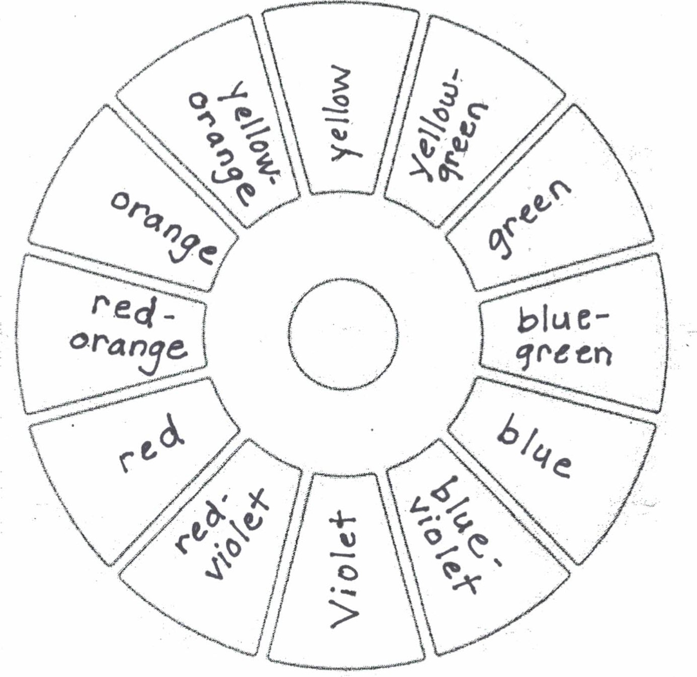

**Color is the quality of an object with respect to light reflected by the object, usually determined visually by measurement of hue, saturation, and brightness of the reflected light.**

**Hue** is an individual color.

**Primary Colors** are those that cannot be made by combining any other colors; primary color pigments can be mixed to make all other colors. The primary colors are yellow, red, and blue.

**Secondary Colors** are made by mixing two primary colors. The secondary colors are orange, green, and purple.

**Tertiary Colors** are made by mixing a primary color with one of its nearest secondary colors. The tertiary colors are yellow-orange, red-orange, red-violet, blue-violet, blue-green, and yellow-green.

**Complementary Colors** are colors that are opposite each other on the color wheel. They are high contrast when used together in a composition. Red and green, yellow and purple, and blue and orange are complementary. Browns can be made by mixing two complementary colors together; greys can be made by mixing two complementary colors together and adding white.

**Analogous Colors** Analogous colors are groups of three colors that are next to each other on the color wheel, sharing a common color, with one being the dominant color, which tends to be a primary or secondary color, and a tertiary. They are compatible and blend well when used in a composition. Red, red-violet, and violet are analogous.

**Monochromatic Color** is a color scheme that uses only one hue and all the values (tints and shades) of the hue.

**Split Complementary Color** is a color scheme that uses a base color and two analogous colors on either side of the base’s complement.

**Warm Colors** are vivid and energetic. They advance in space and can pop out in a composition. Warm colors include yellow, red, and orange.

**Cool Colors** are serene and soothing. They recede in a composition so fall into the background easily. Cool colors include blue, green, and violet.

**Monochromatic Colors** are the tints and shades of one hue.

**Tints** are the high, lighter values of a color. A tint is made by adding white to a hue, making the color lighter.

**Shades** are the low, darker values of a color. A shade is made by adding black to a hue, making the color darker.

**Saturation** is the brightness or dullness of a color. A highly saturated color is very bright while a desaturated color is very dull.